**NZ Veterinary Locum Network**

Note: The following are the candidate sections of the document. They are presented here for guidance. Questions in each section could be used as possible aspects to cover. Some questions may not be applied to each project. On the other hand, additional information may be needed.

# Introduction

## Purpose

* What is the problem or the opportunity that the project is investigating?
  + Problem: In order to market themselves and look for jobs, there hasn't been a website created exclusively for veterinary locums in New Zealand.
  + Opportunity: Create a website where employers can post job openings for locums and veterinary locums can create profiles and introduce themselves.
* Why is this problem valuable to address?
  + Macro Level: As for now, a platform for veterinary locum to independently advertise themselves outside from a recruitment agency hasn’t existed yet, the only place for them to so is a Facebook group.
  + Applied Level:
    - Scaling this problem down to a veterinary locum so we have a specialized website aimed towards vet clinics looking for locums rather than general doctor’s website.
    - Having both locums and vet clinics contact each other without 3rd party intervention.
    - Instead of having to sift through numerous Facebook postings to determine which locum is credible and accessible for a clinic, our goal is to have all doctors' information in a nice, readable style. Currently, Facebook users cannot access or view the information because it is not made public.
* What is the current state (e.g., unsatisfied users, lost revenue)?
  + Current State:
    - Fragmented information across different Facebook groups or general doctor’s website.
    - Inaccessible to public because the Facebook group is private
    - No platform aside for doctor’s recruitment agency is present for veterinary locums.
    - It is still very difficult for locums and clinics to get in touch with each other without 3rd party intervention (recruitment agency).
    - For new veterinary locums it is very difficult to find a clinic if they don’t have personal connections with clinics because there’s no platform for them to see and know which clinics are in need of them.
* What is the desired state?
  + Future State:
    - In the long run, I hope that this project will enable the centralization of veterinary locums and accessible job lists, enabling locums and clinics to arrange for work without the assistance of a recruitment firm.
    - NZ Veterinary Locum Network will be the only platform to keep track of veterinary locum's profiles that are visible to the public online, filling a specific need for a distinct sector on the website rather than specialized Facebook groups.
    - Allow job listing due date, so when a job listing is expired it will automatically be removed from the website.
* Has this problem been addressed by other projects? What were the outcomes?
  + N/A

## Industry/ domain

* What is the industry/ domain?
  + Veterinary (Healthcare)
* What is the current state of this industry? (e.g. challenges from start-ups)
  + Not enough doctors and locums to cover for NZ’s increasing demand in healthcare.
  + It is difficult for new locums to find a job in the industry due to lack of public information.
* What is the overall industry value-chain?
  + For locums to advertise their services and for clinics to offer jobs to vets locum.
  + Put ads on the website
* What are the key concepts in the industry?
  + Get as many users to register as possible
  + The more users you can get to join your platform, the more ads you can display
  + Get NZ government’s attention to help the development of the platform.
* Is the project relevant to other industries?
  + Centralized profile indexing and job listing information is applicable in concept and execution to a range of different industries

## Stakeholders

* Who are the stakeholders? (Be as specific as possible as to who would have access to the software)
  + Veterinary locums
  + Clinics
  + Early vet graduates who want to become a locum
  + Public users who are looking for a vet
* Why do they care about this software?
  + Veterinary locums:
    - A platform for them to advertise themselves for free to the public.
    - Improved information of clinics looking for locums
    - Single point of visit for job information
  + Clinics:
    - A platform for them to look for locums in their area
    - Improved planning and decision making for their existing vets
    - Improves productivity in the clinic
  + Early vet graduates:
    - Platform to get themselves known to the public
    - Access to clinics looking for a locum
    - The ability to manage their own work without 3rd party intervention
* What are the stakeholders’ expectations?
  + An easy-to-use website
  + A secure login and sign-up system
  + Beautiful UI and UX for public and signed user
  + Centralized platform for all vet locums in New Zealand

# Product Description

## Architecture Diagram

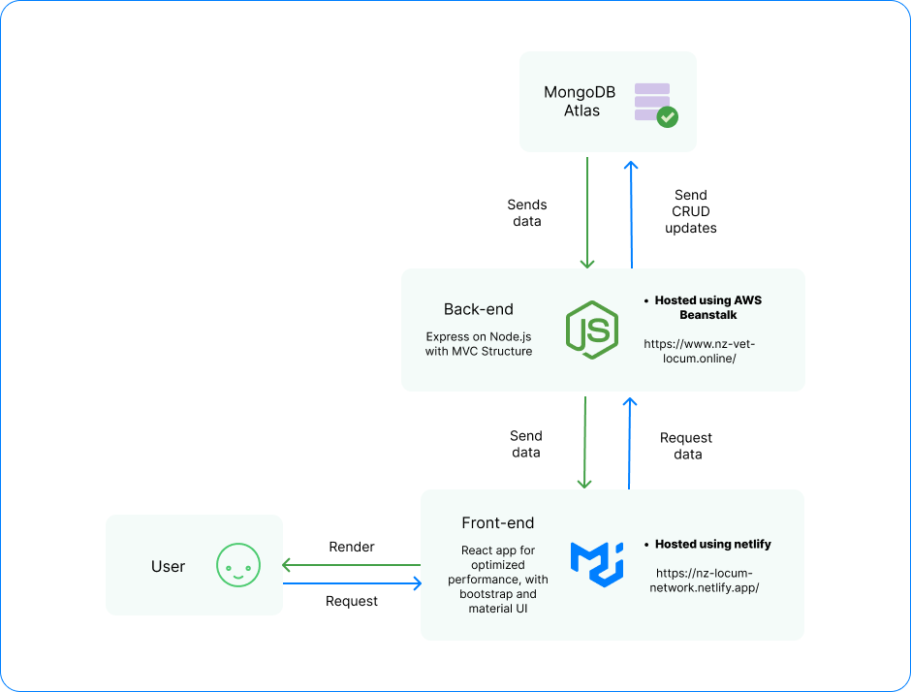

## User Stories

|  |  |  |  |  |
| --- | --- | --- | --- | --- |
| # | User Story Title | User Story Description | Priority | Additional Notes |
| 1 | Vet working in a private practice | As a vet, I want to find out if there’s any available locum to cover for my shift during the week where I’m off. | High |  |
| 2 | Vet clinic | As a clinic admin, I want to make sure that there will always be a vet working during the week when our in-house vet is on leave | High |  |
| 3 | Vet locums | As a locum, I want to advertise myself and get my availability known to the public | High |  |
| 4 | Recent vet graduates | As a recent graduate, I want to find a job as a vet, but I don’t know which clinic I want to work with yet, so I want to be a locum  As a recent graduate, I don’t have any personal contact with the clinics yet, so it is very difficult for me to get a job as most of the available ones are private listings | High |  |
| 5 | General public | As a general user, I want to find a private vet to take care of my dog which are available outside the clinic working hours that I can directly contact to | Medium |  |

## User Flow

<https://www.figma.com/file/GfSwTgQxi3aLKluMZj63wd/NZ-Veterinary-Locum-Flow-Diagram?node-id=0%3A1&t=p1Rq8IYt3Jhmggrt-0>

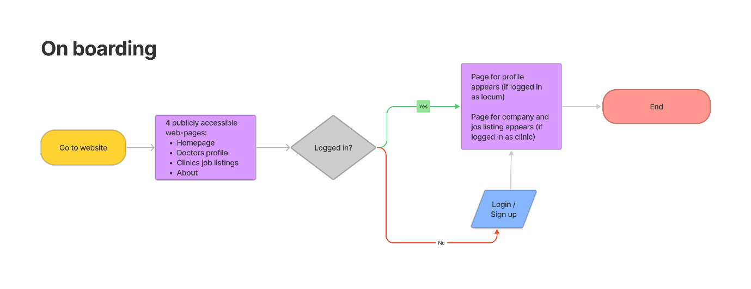

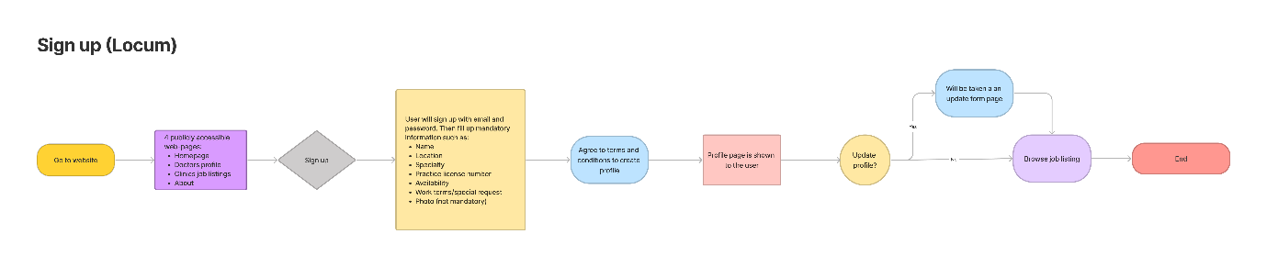

## Wireframe Design

<https://www.figma.com/file/kqeMSGwcqMYjBFViLUcspq/NZ-Veterinary-Locum?node-id=2%3A2&t=A0eA3rnIdJkgSdXF-0>

## Open Questions/Out of Scope

* What features are considered out of scope?
  + Verification of doctor’s licence in the platform (user will have to put their registration number) but as for verification, it will not be done in the platform
  + Redux implementation (would be in scope if I had more time)
  + When you register a user, any uploaded image that's larger than 1 Mb will not go through, this is because the TSL certificate from the cloud server is built with an older version of security policies, your browser won't allow a large file to be sent. The console log will show that it's a CORS issue.
  + More information regarding the TSL certificate can be found here https://docs.aws.amazon.com/elasticloadbalancing/latest/network/create-tls-listener.html

## Non-functional Requirements

* What are the key security requirements? (e.g. login, storage of personal details, inactivity timeout, data encryption)
  + User registration requires a name, email, speciality, availability, and password. The database stores the information as plain text. Each password is hashed 216 (65536) times before being stored in the database. Passwords are stored in the database as hashes rather than plaintext, thus anyone with illegal access to the database would not be able to view a user's password.
* How many transactions should be enabled at peak time?
  + 200/minute
* How easy to use does the software need to be?
  + Compared to other websites, the NZ Veterinary Locum website will be significantly simpler to use because it just concentrates on the essential functions of creating a profile and posting jobs. The method for signing up and posting jobs should be the same as on other platforms.
* How quickly should the application respond to user requests?
  + As fast as possible with the free tier Netlify, AWS Beanstalk and MongoDB Atlas
* How reliable must the application be? (e.g. mean time between failures)
  + NZ Veterinary Locum will strive for an uptime that is as near to 100% as is practical. NZ Veterinary Locum will try to resolve any significant technical issues within two days.
* Does the software conform to any technical standards to ease maintainability?
  + Backend
    - MVC Structure
  + Frontend
    - Custom Hooks implement shared functionality
    - Common elements like profile Items are in separate files and are used by many different parts of the application.
    - Job listings will be in a separate file to maintain easy modifications if needed.

# Project Planning

<https://www.figma.com/file/kqeMSGwcqMYjBFViLUcspq/NZ-Veterinary-Locum?node-id=0%3A1&t=IdnttLOPOBcoOuM0-0>

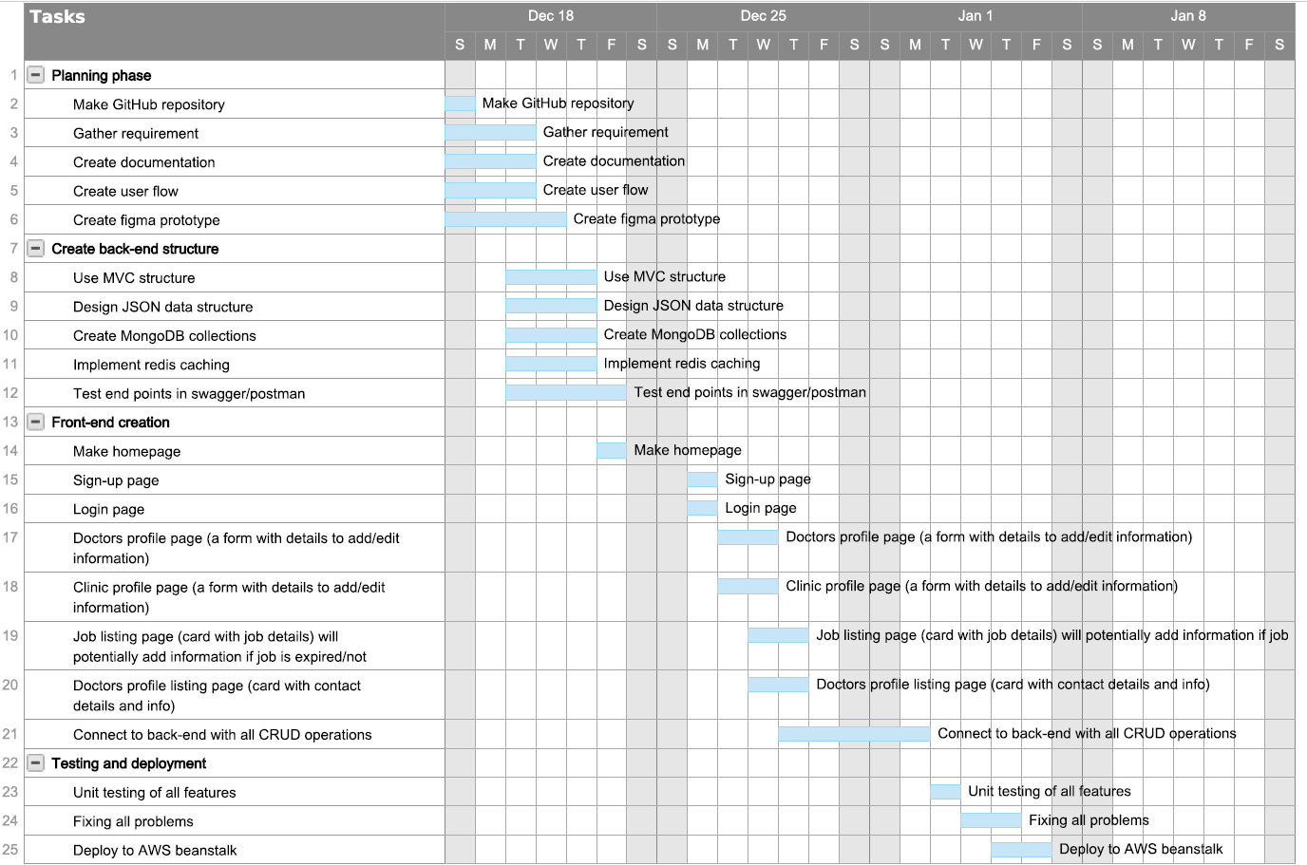

# Testing Strategy

* What were steps undertaken to achieve product quality?
  + Figma prototype design to ensure all the flow works perfectly and all the application structure make sense
  + Ran multiple manual testing
  + Testing on multiple devices with different screen sizes
  + Code is cleanly written with comments on important parts of the code to ensure everyone understands.
  + A well written documentation
* How was each feature of the application tested?
  + Manual testing by me and a couple of other users
  + Unit testing on each feature on development
* How did you handle edge cases?
  + As for edge cases, it will not be the focus of this platform as for now, because in order to achieve a great user experience edge cases need to be planned carefully.

# Implementation

* What were the considerations for deploying the software?
  + Using AWS EC2 with docker-compose (2 docker images: frontend, backend).
  + Use Heroku to deploy front-end and back-end.
* Solution
  + Used AWS beanstalk to handle the back-end deployments, bought a domain to connect to the backend and enabled https secure connection for the front-end.
  + Used Netlify to host the front-end with react build environment.

# End-to-end solution

* How well did the software meet its objectives?
  + The entire list of features that were intended to be created has been completed, and each one functions well.

# References

* Where is the code used in the project? (Link to GitHub)
  + Front-end: <https://github.com/applescan/NZ-Veterinary-Locum-Frontend>
  + Back-end: <https://github.com/applescan/NZ-Veterinary-Locum-CapstoneProject>
* What are the resources used in the project? (Libraries, APIs, databases, tools, etc)
  + • Axios
  + • Bcryptjs
  + • Express.js
  + • MongoDB
  + • MongoDB Atlas
  + • Multer
  + • Node.js
  + • Swagger UI
  + • Bootstrap
  + • CSS
  + • Canva
  + • Figma
  + • React
  + • MUI
  + • MDB Bootstrap